How to import XML reports from BDR-TEST envelopes to FDB

- Open document page in BDR-TEST envelope
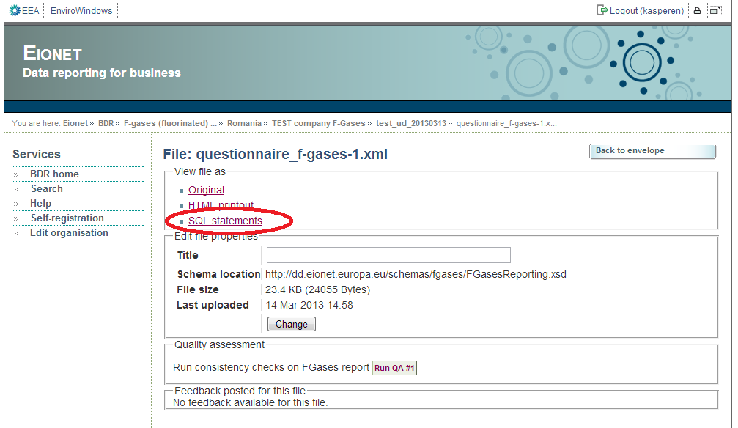
- Save the SQL file in local computer (or alternatively select all SQL statemnt and click „Ctrl + c“)
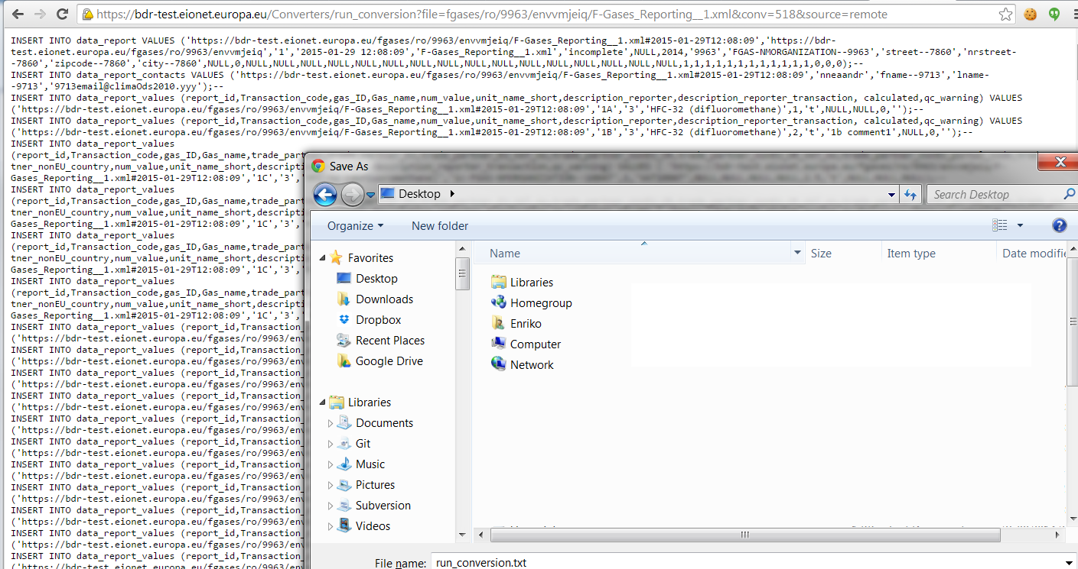
- Select source database and click the button with „green +“ image
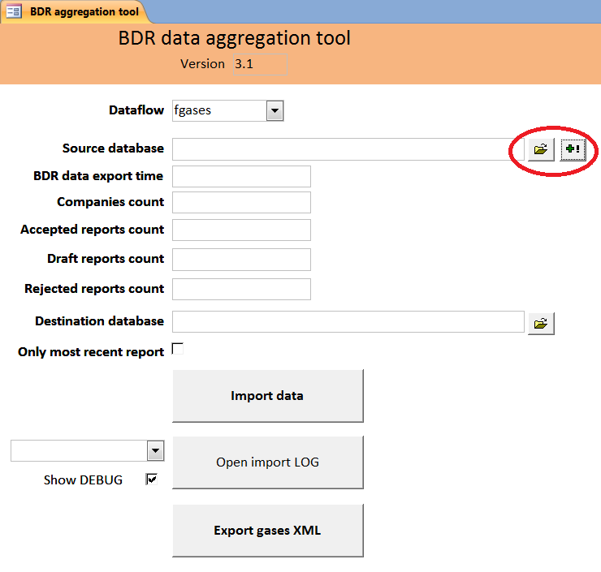

- Select SQL file from local computer(see step 2) or alternatively paste the SQL statements to „Insert data“ form
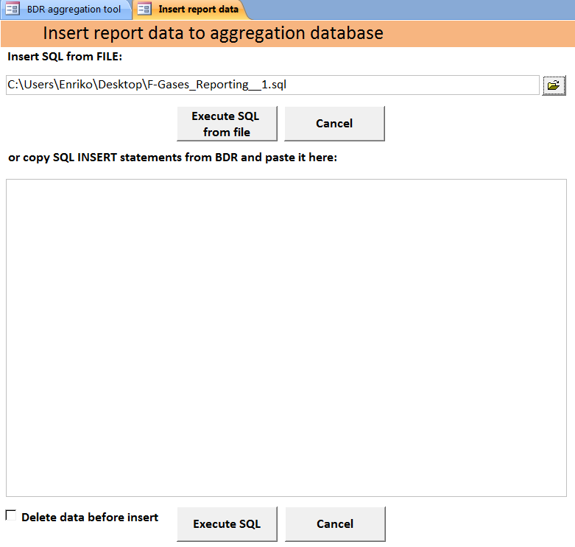
- Check „Delete data before insert“ if you repeat the insert with the same report
- Click "Execute SQL from file" or „Execute SQL“
- Click „Import data“ on main form
